Economic Graphs
GDP: Gross Domestic Product-the value of goods and services produced in the US during a year
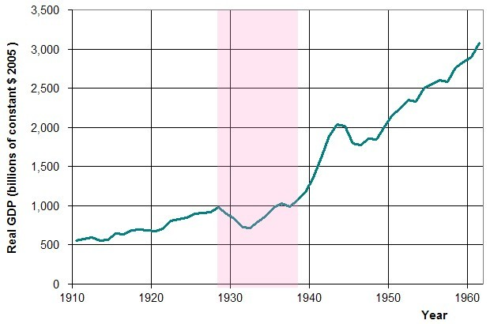
The graph below picks up at this point. Keep in mind that the graph below goes up to $14 trillion, while this graph ends at $2 trillion.
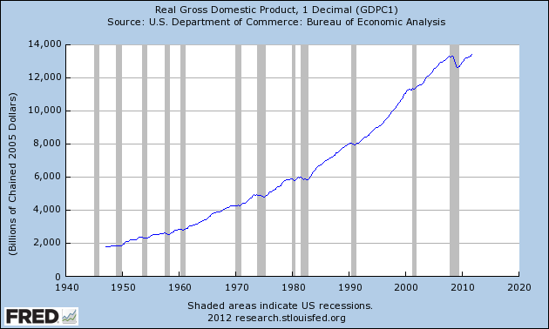

Growth in GDP: Rather than looking at the total value of what was produced the following graphs look at how much GDP grew or shrank throughout the last decade. Q1 is Jan-March, Q3 is July-September. The years are listed after the quarter in the first graph, and before in the second graph.
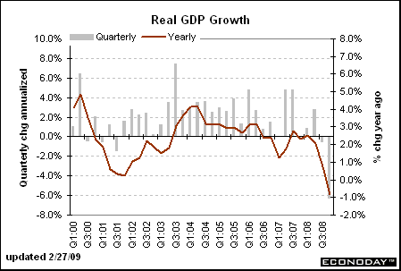
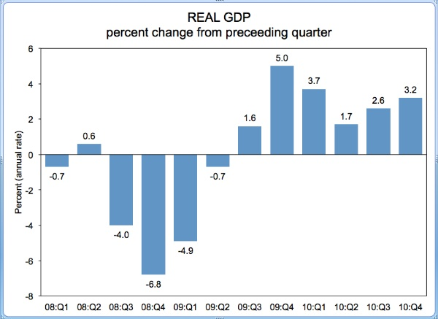

Unemployment: The number of people (%) who want a job, are actively looking for a job, and haven’t found one. (People who give up looking for a job are NOT counted as unemployed.)
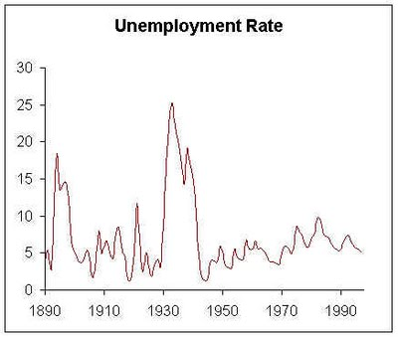
This line is the top % in the graph below.
(Graph above does NOT contain official government data-different method of calculating unemployment was used before WWII)
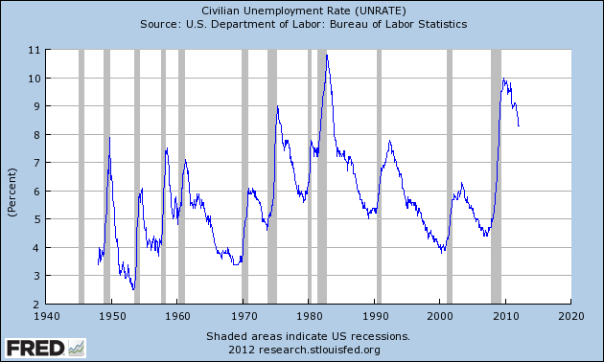

Duration of Unemployment: how long in weeks it takes someone who is unemployed to find a new job
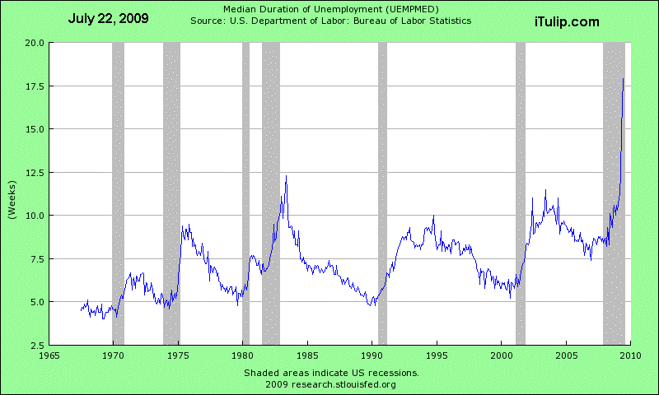

Consumer Price Index(CPI): method of calculating inflation (increase in prices for the same goods); 100 is the base year so a number of 200 means prices doubled in comparison to the base year; so between 1982 and 2007 prices in America doubled. Notice that a flat line means prices are rising slowly and a steep line means prices are rising quickly.
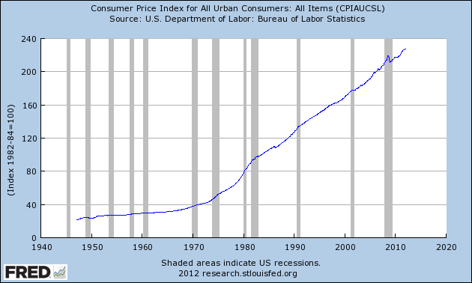
Inflation Rate: how much did prices increase or decrease as a % change when comparing one year to the year before.
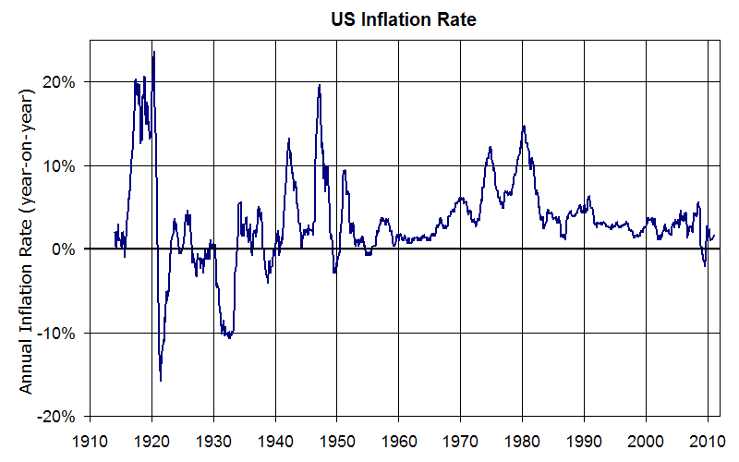
Income Equality/Inequality: How much of the growth in income in America went to top earners and how much went to the bottom 90% of workers.
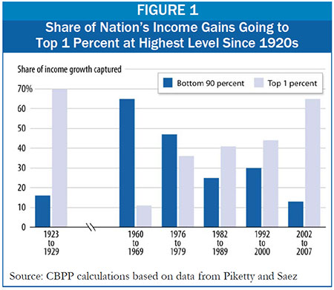
Bank Failures and Income Held by top 10% of Wage Earners: Red line shows % Income held by the top 10% of wage earners. This line is just a different way to present the data from the bar graph above. The Yellow line shows the money banks could not give back to the people who deposited money in their banks. The Blue area shows the number of banks that failed.
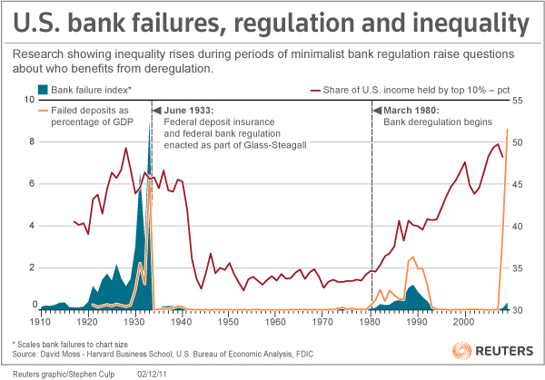
Consumer Spending: Percentage of the American Economy that is made up of spending by households.
