Name_____________________
Hr._____
Immigration Propaganda
Instructions- As you are going through each picture analyze tell me what you see and what is the view on immigration or certain immigrant groups.
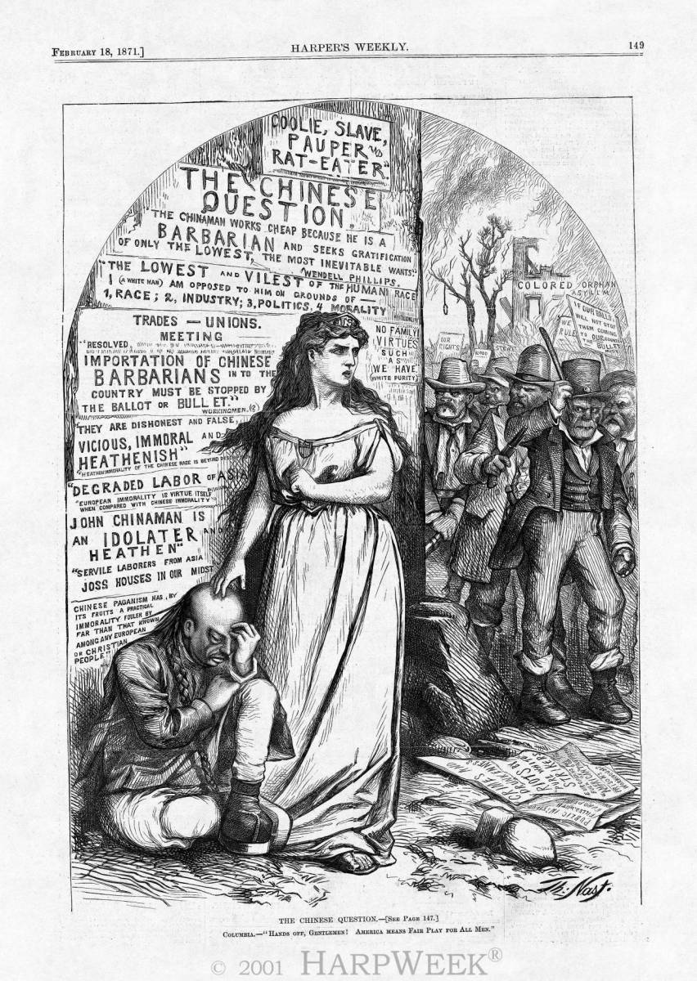
#1 Describe the Cartoon

What is the Message?

#2
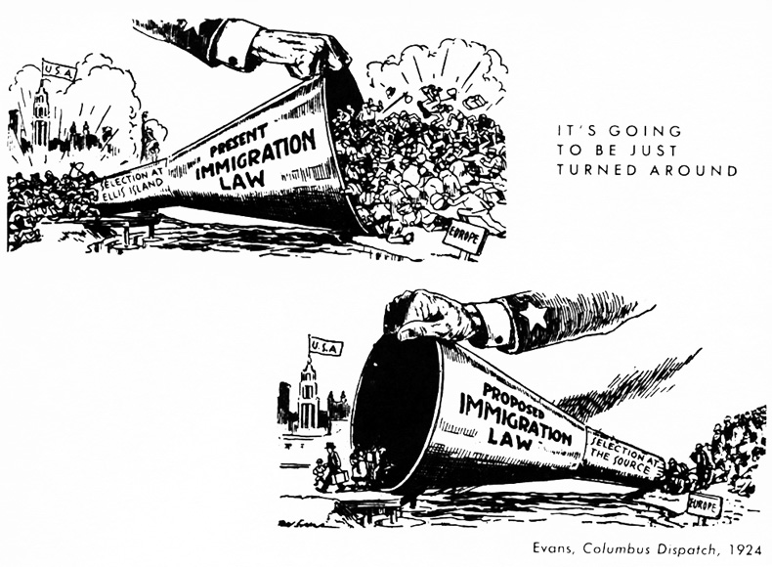
Describe the cartoon

What is the message?

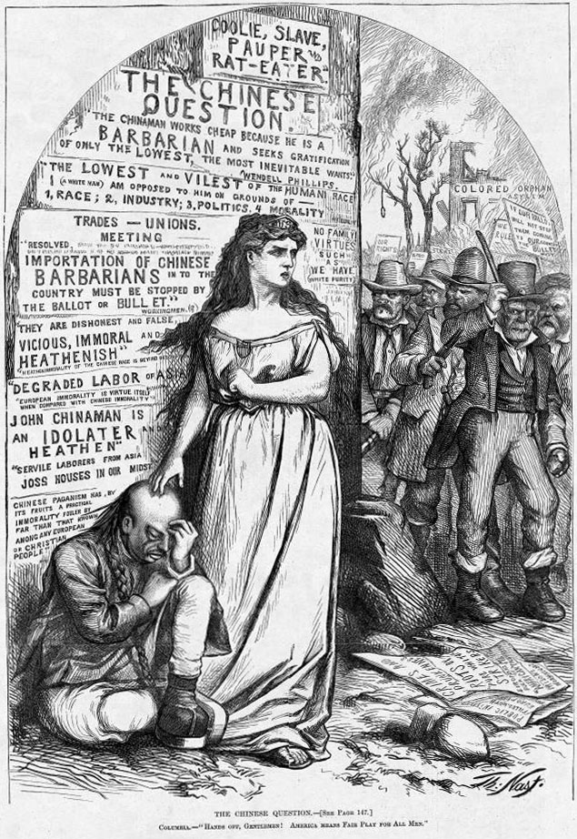

#3 Describe the cartoon
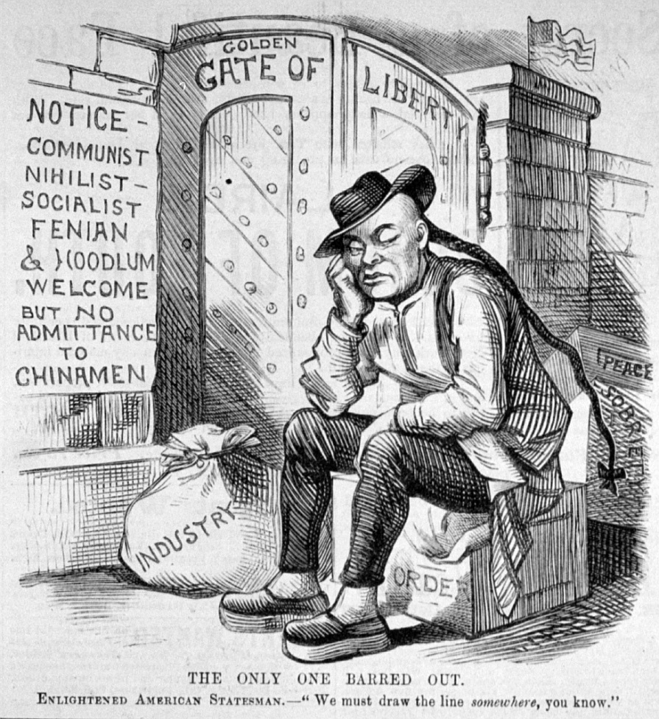

What is the message?

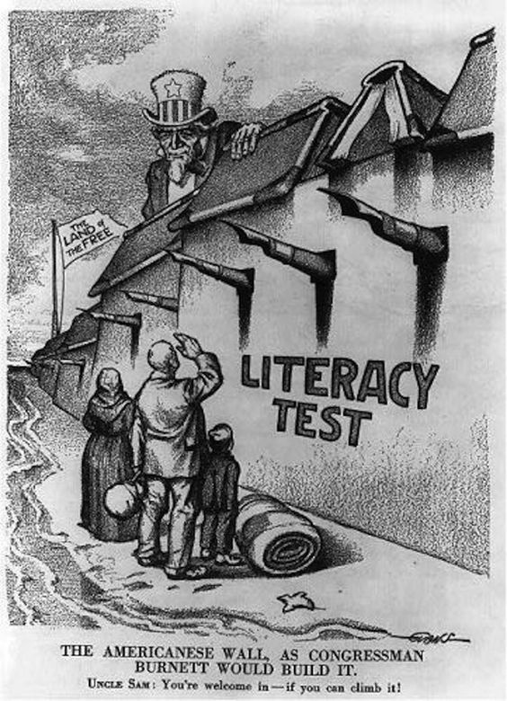
#4
Describe the cartoon

What is the message?

