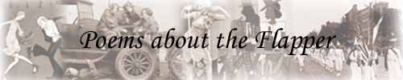
 | 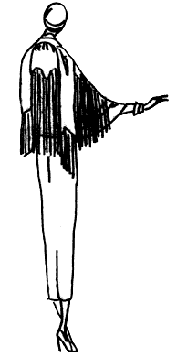 | The Flapper  By Dorothy Parker  The Playful flapper here we see,  The fairest of the fair.  She's not what Grandma used to be, --  You might say, au contraire.  Her girlish ways may make a stir,  Her manners cause a scene,  But there is no more harm in her  Than in a submarine.  She nightly knocks for many a goal  The usual dancing men.  Her speed is great, but her control  Is something else again.  All spotlights focus on her pranks.  All tongues her prowess herald.  For which she well may render thanks  To God and Scott Fitzgerald.  Her golden rule is plain enough -  Just get them young and treat them  Rough.

